**Project**

**Computer Networks**



**Submitted to Ms. Asma Abubakr  
Submitted by M.Naqeeb**

**Roll #: SU92-BSSEM-F22-100  
Section: SE-5B**

**Submitted on Dec 05, 2024**

**DEPARTMENT OF SOFTWARE ENGINEERING  
SUPERIOR UNIVERSITY, LAHORE**

Restaurant Netoworking System

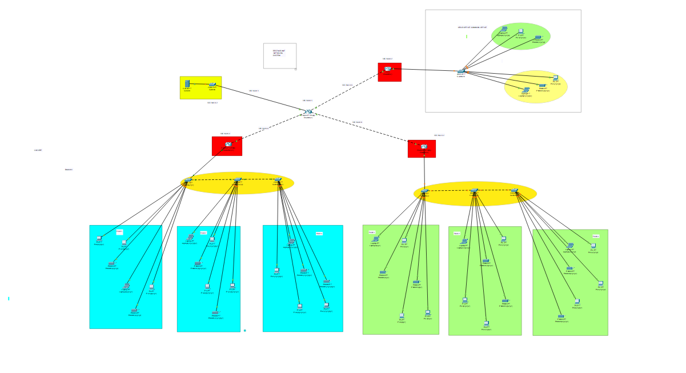

**Restaurant Networking System Documentation**

**Overview**

The restaurant networking system facilitates communication and operational management between various entities within the restaurant. The network ensures seamless data transfer, connectivity, and interaction between different subsystems such as ordering, payment processing, kitchen management, and external systems. This document outlines the architecture, components, and functionality of the system.

**Network Architecture**

The system is organized in a hierarchical structure with multiple interconnected components, including routers, switches, servers, and endpoint devices. The architecture is designed to ensure efficient communication across different departments of the restaurant.

**Key Features:**

1. Centralized network control for streamlined operations.
2. Segregation of devices into logical groups for better performance and security.
3. Redundancy mechanisms to ensure fault tolerance and reliability.

**Components**

**1. Core Network Devices**

* **Routers (Red Nodes):**
  + Manage external and internal network traffic.
  + Provide connectivity between branches, the main office, and external services.
* **Switches (Yellow Nodes):**
  + Connect endpoint devices (e.g., workstations, printers, kitchen monitors).
  + Aggregate traffic within local departments.

**2. Servers**

* **Central Server:**
  + Hosts critical applications for inventory, customer data, and order management.
  + Ensures secure data access and storage.
* **Payment Gateway Server:**
  + Manages payment processing.
  + Interfaces with external financial systems.

**3. Endpoint Devices**

* **Point of Sale (POS) Terminals:**
  + Located at cashier desks for handling customer orders and payments.
  + Connected directly to the payment gateway and inventory system.
* **Kitchen Monitors and Printers:**
  + Display or print orders for chefs to prepare.
* **Employee Workstations:**
  + Used for managing reservations, inventory updates, and administrative tasks.

**4. Branch Connectivity**

* Each branch operates with its own subnet.
* All branches are connected to the central office via routers.
* Secure VPN tunnels are used for data protection during inter-branch communication.

**5. Wireless Access Points**

* Enable staff and customer access to the network within the restaurant premises.
* Operate on separate VLANs to segregate guest traffic from internal systems.

**Network Functionality**

**1. Order Processing**

* Orders are placed at the POS terminals and transmitted to the central server.
* The central server communicates with the kitchen monitors for preparation.
* Payment data is processed through the payment gateway server.

**2. Inventory Management**

* The system tracks inventory usage in real-time.
* Alerts are generated when stock levels drop below predefined thresholds.

**3. Customer Data Management**

* Customer details are securely stored for loyalty programs and personalized services.

**4. Inter-Branch Coordination**

* Orders and inventory data are synchronized across all branches.
* Centralized reporting provides insights into sales and operations.

**Security Measures**

1. **Firewalls:** Protect against unauthorized access.
2. **Encryption:** Secures sensitive data such as payment details and customer information.
3. **Access Control:** Restricts device and user access based on roles.
4. **Regular Backups:** Ensure data recovery in case of failure.

**Github Link:**

**https://github.com/Naqeeb-Bro/Naqeeb-100-5B-lab-tasks-updated-/blob/main/Restaurant%20Networking%20System.pkt**

--------------------------------------------------------------------------------------------------------------